**Project Design Phase**

Phase 3

Data Flow Diagram & User Stories

|  |  |
| --- | --- |
| Date | 23 October 2023 |
| Team ID | SI-GuidedProject-587558-1696963149 |
| Project Name | A Sleep Tracking App For A Better Night's Rest |
| Maximum Marks | 4 Marks |

# Data Flow Diagrams:

A Data Flow Diagram (DFD) is a traditional visual representation of the information flows within a system. A neat and clear DFD can depict the right amount of the system requirement graphically. It shows how data enters and leaves the system, what changes the information, and where data is stored.

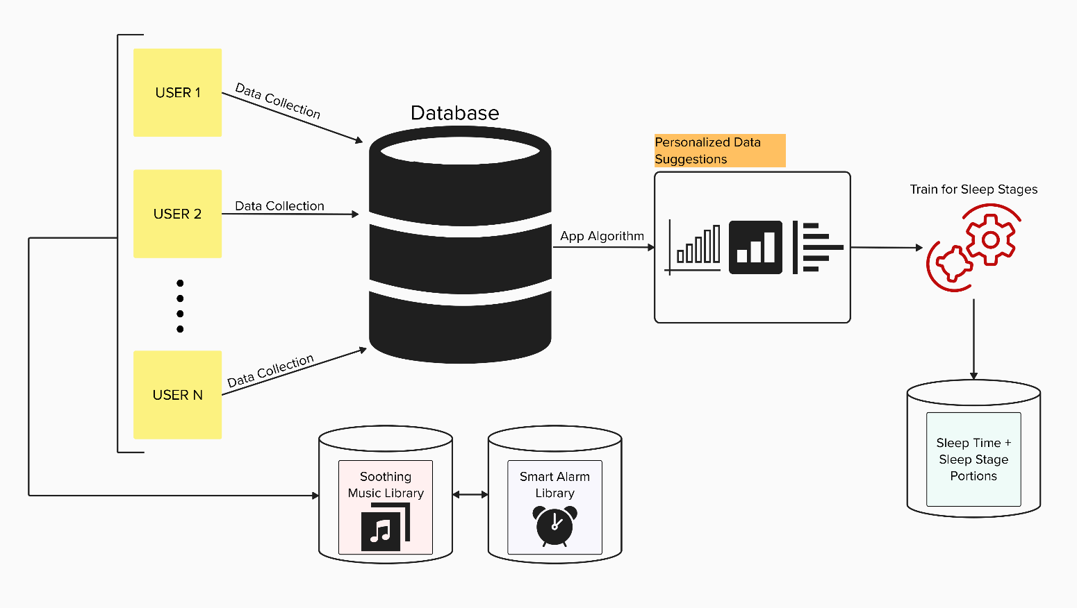

**User Stories**

|  |  |  |  |  |  |  |
| --- | --- | --- | --- | --- | --- | --- |
| **User Type** | **Functional**  **Requirement (Epic)** | **User Story Number** | **User Story / Task** | **Acceptance criteria** | **Priority** | **Release** |
| Customer (Mobile user) | Registration | USN-1 | As a user, I can register for the application by entering my email, password, and confirming my password. | I can access my account / dashboard | High | Sprint-1 |
|  |  | USN-2 | As a user, I will receive confirmation email once I have registered for the application | I can receive confirmation email & click confirm | High | Sprint-1 |
|  | Login | USN-3 | As a user, I can log into the application by entering email & password |  | High | Sprint-1 |
|  | Sleep Tracking and Improvement | USN-4 | As a user, I want to track my sleep patterns by inputting my bedtime and wake-up time. | The app successfully records my sleep patterns. | High | Sprint-1 |
|  |  | USN-5 | As a user, I want to receive personalized recommendations for improving my sleep quality based on the analysis of my sleep data. | The app provides me with tailored sleep improvement suggestions. | Medium | Sprint-2 |
|  | Relaxation and Sound Library | USN-6 | As a user, I want access to a library of calming sounds and white noise to create a soothing sleep environment. | The app allows me to select and customize calming sounds for a peaceful sleep environment. | Medium | Sprint-1 |
|  | Smart Alarm and Wake-Up | USN-7 | As a user, I want to set a smart alarm that wakes me up at the optimal point in my sleep cycle for a more refreshing wake-up. | The smart alarm effectively wakes me up at the optimal time. | Medium | Sprint-1 |
| Data Analyst | Requires Data | USN-8 | As a data analyst, I want to get my sleep data so that I can check my tendencies. | The app gives accurate data to the analyst. | Low | Sprint-3 |